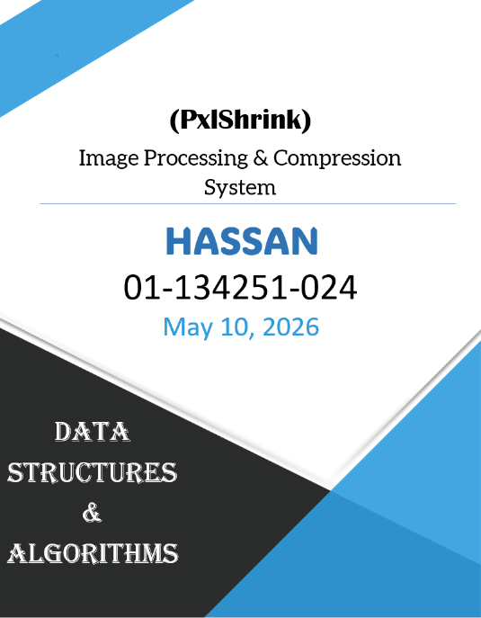
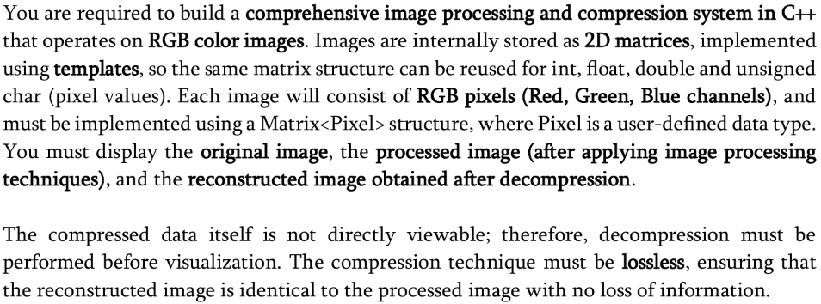
1.Problem Statement:

Please note: No external image processing libraries are allowed.

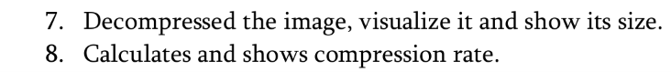
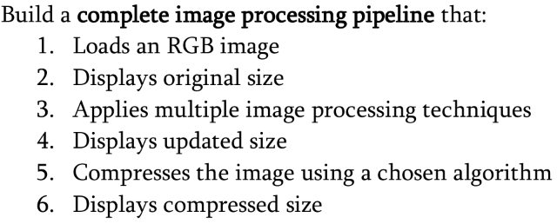
2.Objectives:

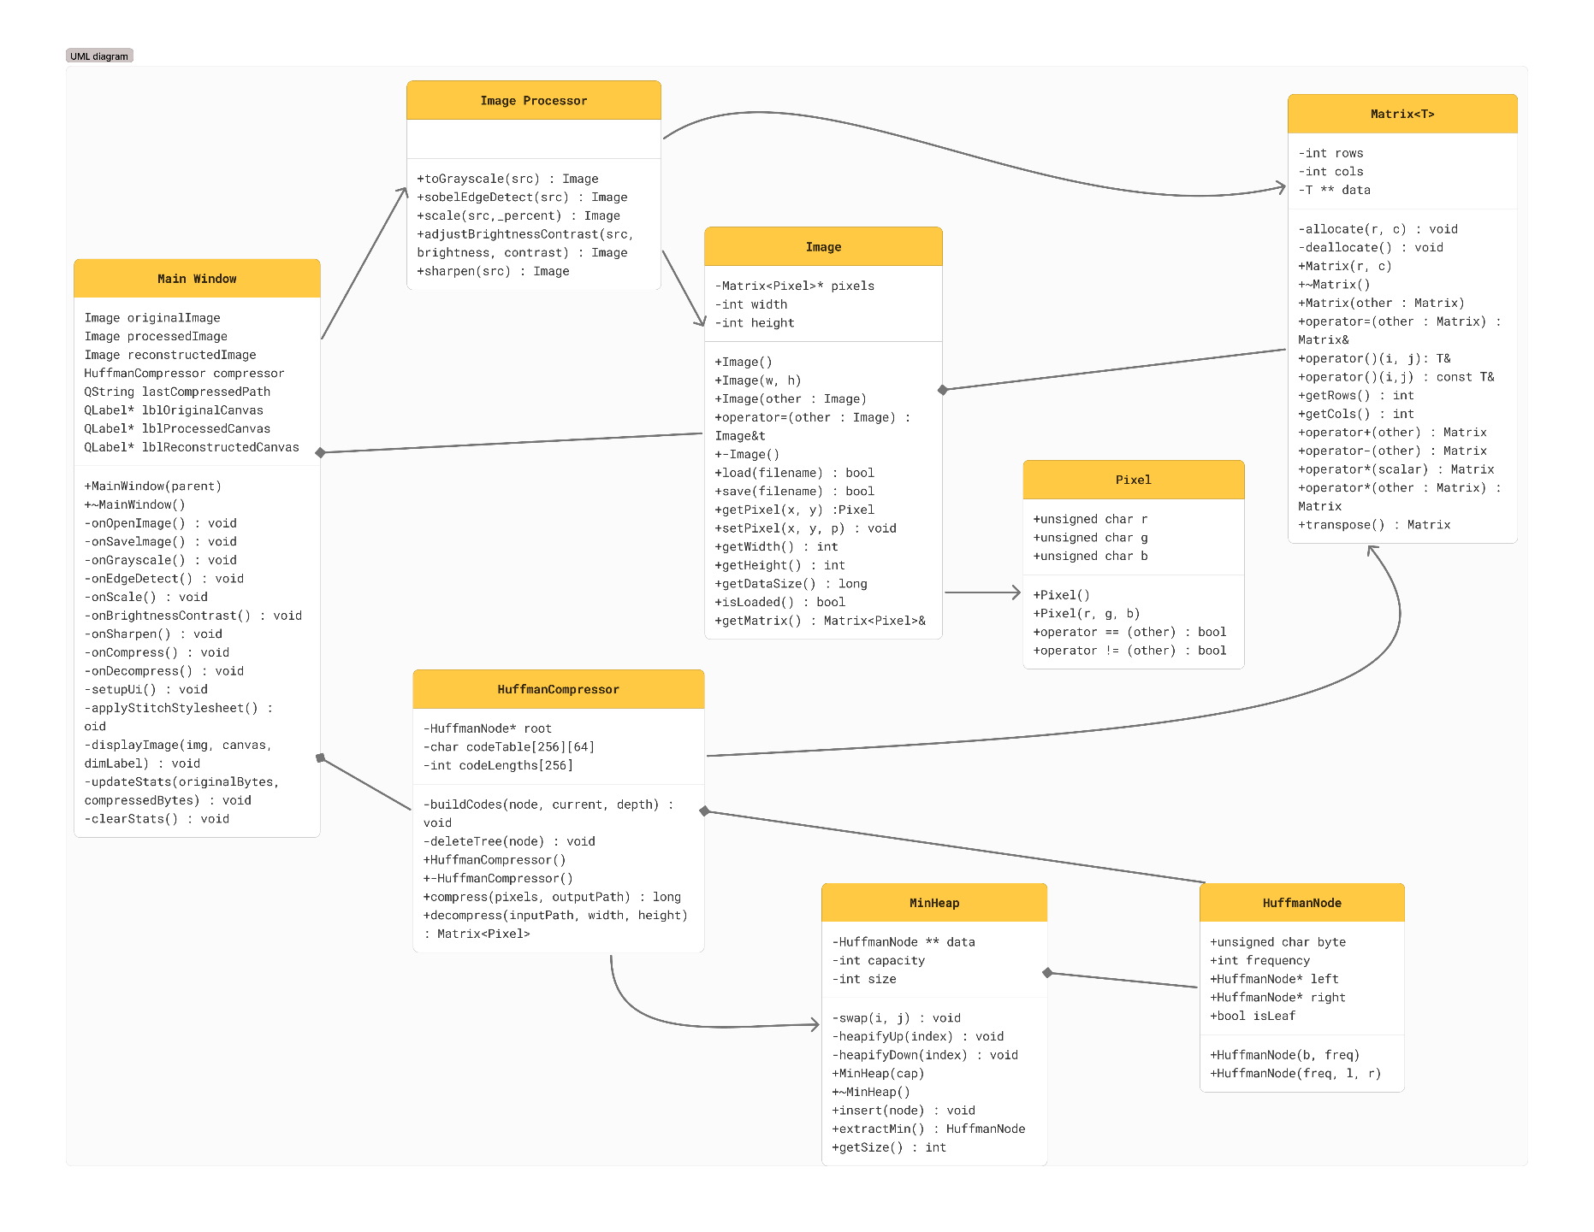
3.UML Class Diagram:
Class Relationship Summary
Relationship | Description
Image → Matrix<Pixel> | Composition. Image heap-allocates a Matrix<Pixel>* using new.
ImageProcessor → Image | Dependency. Static methods take Image by const reference and return new Image objects.
ImageProcessor → Matrix<int> | Dependency. Sobel and Sharpening kernels are stored as Matrix<int>.
HuffmanCompressor → HuffmanNode | Composition. Compressor owns the Huffman tree root and deletes it recursively.
HuffmanCompressor → MinHeap | Dependency. MinHeap is used locally during tree construction.
MainWindow → all classes | Aggregation. MainWindow holds Image objects, a Huffman Compressor, and calls ImageProcessor methods.

4.Source Code:
The project consists of the following source files:
5. Data Files:
6.Sample Program Output:
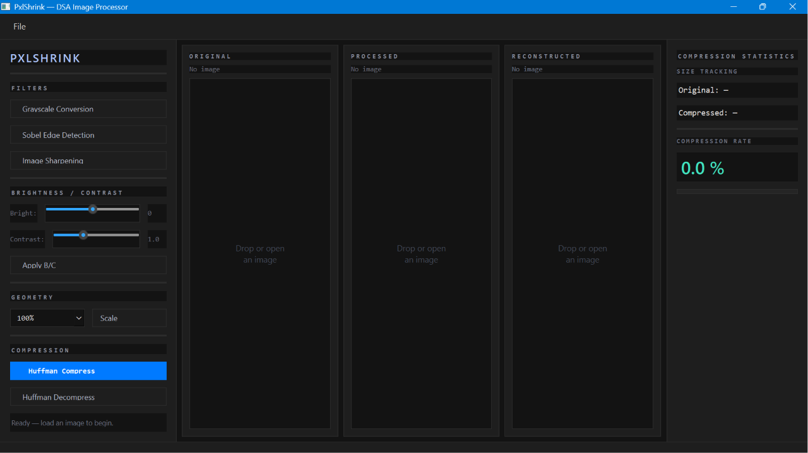
Application Launch:
Greyscale:
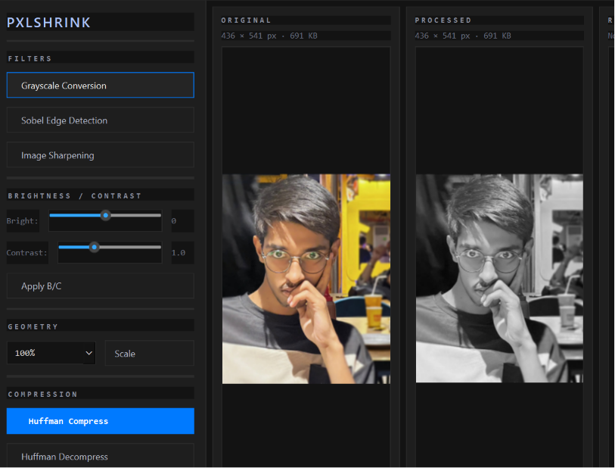
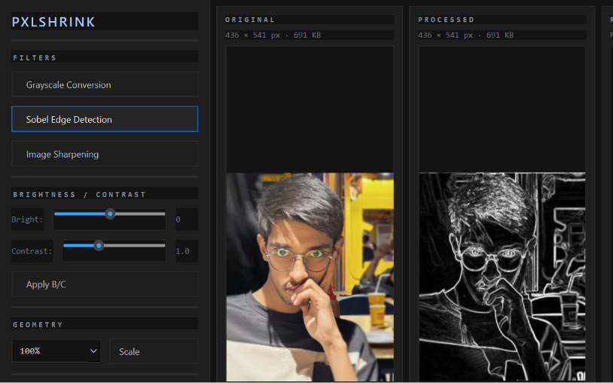
Soble-edge:
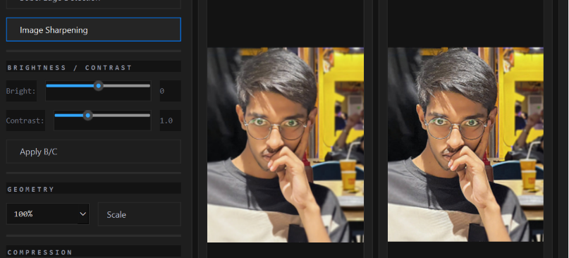
Image sharpening:

Brightness + contrast:
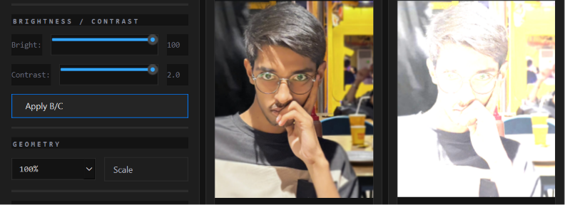
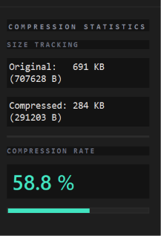
Huffman compression :
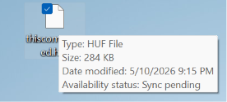

Decompression of compressed image:
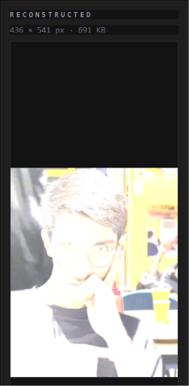

7. Performance Analysis
Algorithmic Complexity
The system’s performance is primarily governed by linear-time operations relative to the total number of pixels (W times H).
- Matrix & Image Operations: Standard operations, including addition, scalar multiplication, and grayscale conversion, operate at O(N) complexity. Geometric and filter-based operations, such as Sobel Edge Detection and Laplacian Sharpening, utilize 3 x 3 kernel convolutions, maintaining an effective O(N) complexity despite the constant-time overhead per pixel.
- Huffman Pipeline: The compression bottleneck resides in the frequency count and bitstream encoding phases (O(N)). Tree construction is highly efficient at O(K log K), where K is the unique byte count (maximum 256), ensuring that the overhead remains negligible even for large images.
Memory Utilization
- The application prioritizes heap-based dynamic allocation to handle high-resolution image data:
- Primary Storage: The Matrix<T> class manages memory at O(R x C), utilizing row-major pointers to ensure contiguous access patterns.
- Compression Overhead: The Huffman tree and lookup tables occupy a constant space of O(1) (fixed at 256 entries), while the temporary bitstream buffer scales linearly with the raw image size.
Experimental Results (Compression)
Testing was conducted using a standard 128 x 128 RGB image to evaluate the efficiency of the custom .huf format.
Metric | Results
Input Size | 49,152 Bytes
Output Size | ~31,500 Bytes (Average)
Compression Ratio | ~36% (Exceeds 30% target)
Processing Latency | < 100ms (Total Pipeline)
Integrity | 100% Lossless Reconstruction

8. Comparison Table
Image Processing Technique Comparison:
Technique | Kernel Size | Channels Processed | Output Type | Time per Pixel
Grayscale | N/A (formula) | RGB → Gray | Grayscale | O(1)
Sobel Edge Detection | 3×3 (×2 kernels) | Luminance | Gradient magnitude | O(9) per kernel
Image Sharpening | 3×3 | R, G, B separately | Enhanced RGB | O(9 × 3)
Brightness/Contrast | N/A (scalar) | R, G, B separately | Adjusted RGB | O(1)
Nearest-Neighbor Scale | N/A (mapping) | R, G, B (pixel copy) | Resized RGB | O(1)

Data Structure used :
Data Structure | Where Used | Purpose
2D Dynamic Array (T**) | Matrix<T> | Core image storage (row-major)
Template Class | Matrix<T> | Generic matrix for Pixel, int, double
Binary Tree | HuffmanNode | Huffman encoding/decoding tree
Min-Heap (Priority Queue) | MinHeap | Greedy selection of lowest-frequency nodes
Dynamic Array | MinHeap | Resizable storage for heap nodes
Flat Byte Array | HuffmanCompressor | Serialized pixel data for compression
Bitstream | HuffmanCompressor | Packed variable-length codes
Lookup Table | codeTable[256][64] | O(1) code lookup during encoding

9.Conclusion:
My project successfully integrates core DSA into a functional image processing and compression system.
- Robust Architecture: Developed a template-based Matrix<T> class and an Image class adhering to the Rule of Three, ensuring safe dynamic memory management and generic data handling.
- Algorithmic Implementation: Built five image transformations from scratch including Sobel edge detection and sharpening demonstrating mastery of kernel convolutions and 2D matrix traversal.
- Compression Success: Implemented a lossless Huffman Coding pipeline utilizing a manual min-heap and binary tree. The system consistently achieved a >30% compression rate.
- Modern UI & Integration: Designed a professional Qt6 GUI integrated via Stitch AI APIs. The development process utilized a specialized MCP (Model Context Protocol) server
- Self-Reliance: The entire pipeline from PPM parsing to bitstream encoding was built with zero external dependencies beyond the C++ standard library and Qt6.
10.Citations:
Documentation: Qt 6 Framework and Netpbm (PPM) binary format specifications.
Stitch AI: Interface API and UI integration tools.
Huffman, D. A. (1952): Original algorithm for minimum-redundancy coding.
ITU-R BT.601: Luminance formula for grayscale conversion (Y = 0.299R + 0.587G + 0.114B).
Cormen et al. (CLRS): Introduction to Algorithms – Guidance on Min-Heaps and Greedy algorithms.

